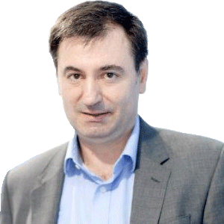

Arjan Gjonça, PhD
Professor of Demography at Department of International Development, London School of Economics and Politics Science.
Arjan Gjonça is a demographer at London School of Economics. He holds a PhD in Demography from LSE. Dr Gjonça’s work experience includes institutions such as Max Planck Institute for Demographic Research; University of Southampton; University of Bocconi, and Department of Social Policy at LSE.
He is a member of different professional bodies, and has held leading and honorific positions in many of them, including International Union for the Scientific Study of Population, British Society for Population Studies (Honorary Secretary), European Association for Population Studies, Population Association of America, DemoBalk Association (Vice-President) and many more.
Dr Gjonça has acted as an adviser to different international organisations and national governments, including the World Bank, UNFPA, UNDP, UK Government, Albanian Government, Turkish Government, Kosovo and Bosnian Governments. His recent contribution includes chairing the Commission on the Reform of Higher Education in Albania (2013-2015); co-chairing the expert group of Scientific Research of the Berlin Process on Western Balkan Countries in 2015-2017, and Chair of the Accreditation Board of Higher education in Albania (2015-2021).
Dr Gjonça’s research interests and publications focus on health and mortality transitions in developing countries; demography of the Balkans; sex imbalances at birth and female disadvantages in health and mortality in developing countries as well as the interplay between development and tradition in shaping demographic and behaviour. Arjan’s research has been published in world rated demographic and epidemiological journals such as Population Studies, Population and Development Review, The LANCET and many more.

